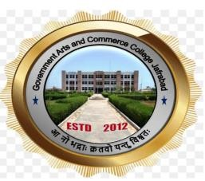

GOVERNMENT ARTS AND COMMERCE COLLEGE, JAFRABAD

‘STUDENT SENSITIZATION SEMINAR ON SSIP’

REPORT OF SEMINAR HELD ON 1st March 2024

COMMITTEE SSIP

Co-ordinator Principal
Prof Yamuna Panicker Dr. Viralkumar Shilu

Objective of the Seminar
The Student Startup and Innovation Committee of the college conducted the Seminar. The main objective of the seminar was to sensitize the students regarding startup and SSIP policy.

Resource Person
Dr. Sumit Acharya– Faculty at Swaminarayan Institute of Management and IT, Porbandar

About the Seminar

At the beginning Prof. Yamuna Panicker-Coordinator, SSIP, welcomed the participants to the event and the programme, Thereafter, Dr. Viralkumar Shilu, Principal welcomed the guest speaker Dr. Sumit Acharya.
Dr. Sumit Acharya delivered his lecture about Startup ecosystem which was heartily welcomed by the students. Post his lecture he also interacted with the group of students of the college who were interested in starting a Moringa based health drink. Thus, our students were benefitted by his expertise.

